Science, Gr. 9
Atoms & Elements – Physical Properties of Matter

Particle Theory of Matter
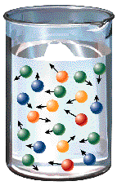
The "Particle Theory of Matter" states that:

1.
2.

3.

4.

5.

Under normal conditions, matter is found in one of states:
- Solid : ____________________________
- Liquid : ____________________________
- Gas: ____________________________

The particles are the in each state!
- They are just ____________________________
- They just have ___________________________

States of Matter  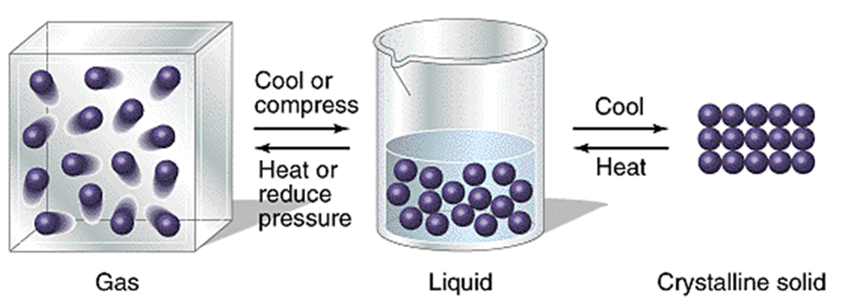 | Changes of State  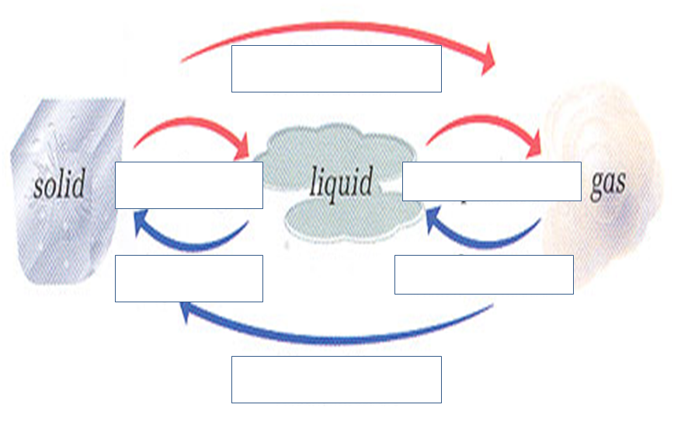
Solids Liquids and Gases

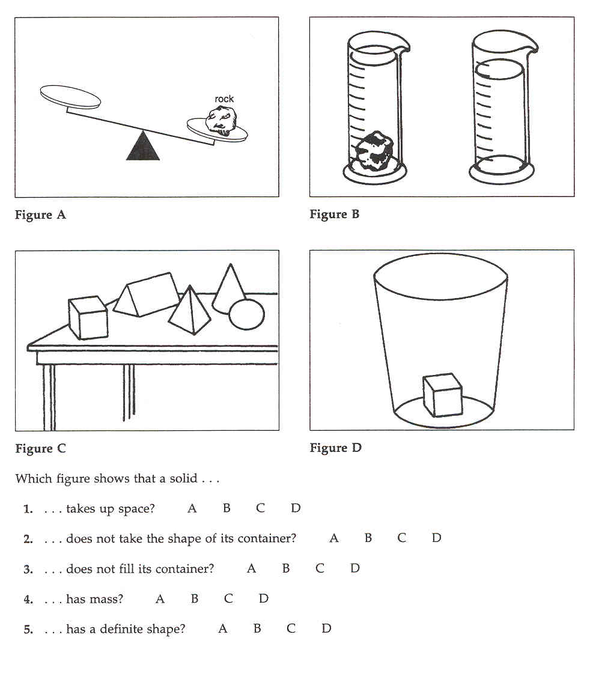
Solids
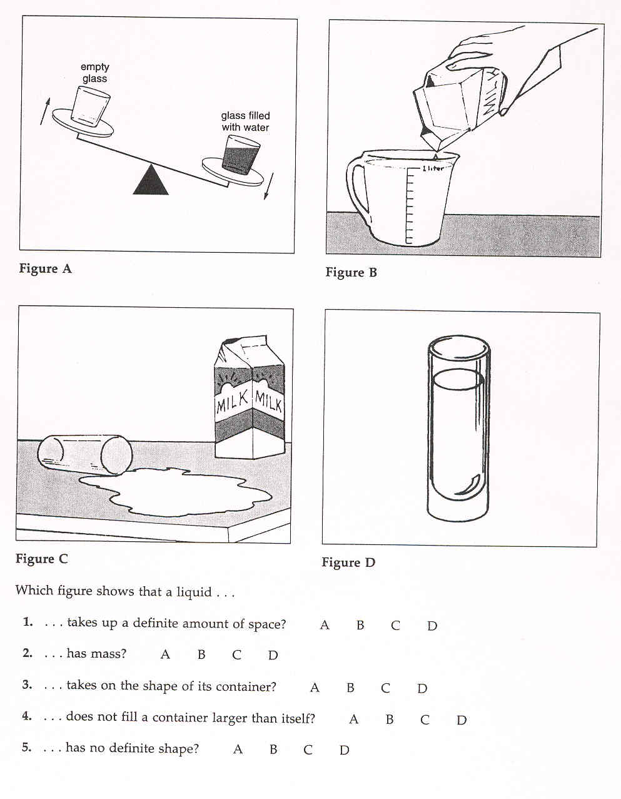
Liquids
Gases
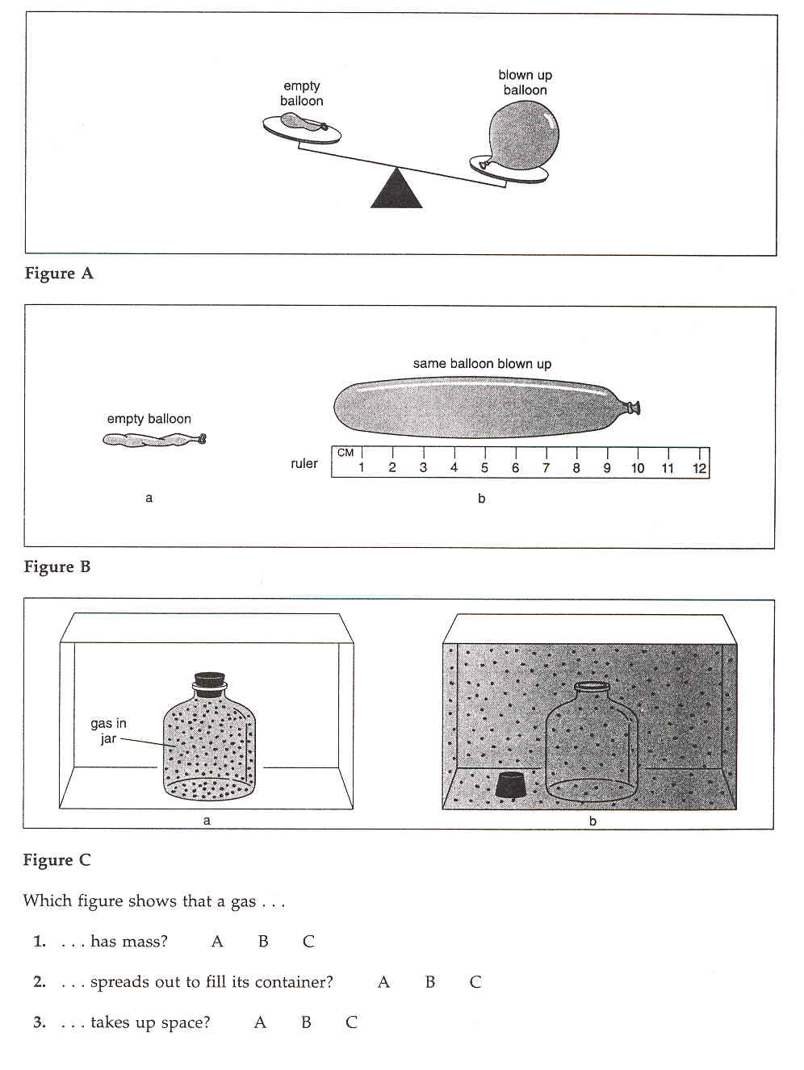
Complete this table

state | have mass | take up space | take up a definite amount of space | have definite shapes | spread out to take shape of its container | small amounts fill large containers | can be invisible
solids | YES
liquids
gases |  |  |  | NO

1. Which properties do all solids, liquids, and gases have?
______________________________________________________________________________

2. Which properties do only gases have?
______________________________________________________________________________

3. Which property do solids and liquids have the gases do not have?
______________________________________________________________________________

4. Which property do only solids have?
______________________________________________________________________________

5. Which property do liquids and gases have the solids do not have?
______________________________________________________________________________

